Commissioning Instructions

**Part 1 – Fitting valve devices.**

For each valve:

1. Build HomeOS with the Valve Driver project
2. Open the file Hub/output/Configs/Config/Scouts.xml in a text editor and change the line  
   <Scout Name="HomeOS.Hub.Scouts.Gadgeteer" DllName="HomeOS.Hub.Scouts.Gadgeteer.dll"/>  
   to  
   <Scout Name="HomeOS.Hub.Scouts.Valve" DllName="HomeOS.Hub.Scouts.Valve.dll"/>
3. Run the HomeOS project and set up the valve device as described in the HomeOS documentation
4. Insert batteries into valve device
5. When A1 shows, valve device will retract control pin (position set to 0%)
6. A2 will be shown. Install valve device onto radiator. Press button located under battery cover.
7. Valve device will calculate minimum and maximum positions.
8. When valve shows 0% and antenna symbol blinks, valve device has been fitted successfully.

Information for trouble shooting such as the error codes shown on the valve devices is available on FHT-8V instruction leaflet: <http://www.elv-downloads.de/service/manuals/62522_FHT8V_eQ3_um.pdf>

**Part 2 – Setting Addresses and initial positions**

1. Press and hold the button on the first valve device until a beep is sounded
2. Transmit an address to the valve by clicking “Set up new valve”. Valve will beep and solid antenna symbol and 0% will be displayed.
3. Repeat steps 1 and 2 for each valve in turn

Each valve will be addressed with increasing numbers from 1.

The drop down box for setting positions with will populate with the valve numbers as each are sent addresses. (Positions cannot be sent until setup is complete.)

1. When last valve has received address, click “Done Setting up Valves”. All of the valves should beep and set their position to 30%.

**Part 3 – Controlling valves**

* To set the same position for all valves, enter a percentage value in the input box below “Set all valve Positions” and click “set all valves”. The valves will change their positions to the set valve within 2 minutes.  
  0% turns the valve fully off and 100% turns it on completely.
* 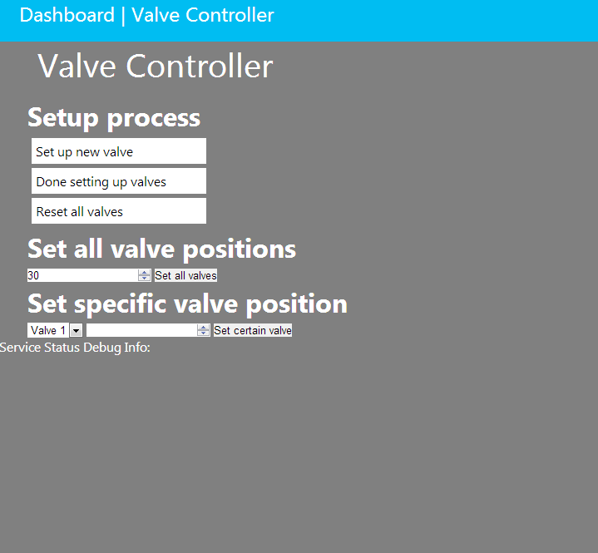To set a specific valve, select its number from the drop down box and enter a value (again, percentage between 0 and 100) and click “Set the valve”. The valve will change its position within 2 minutes.